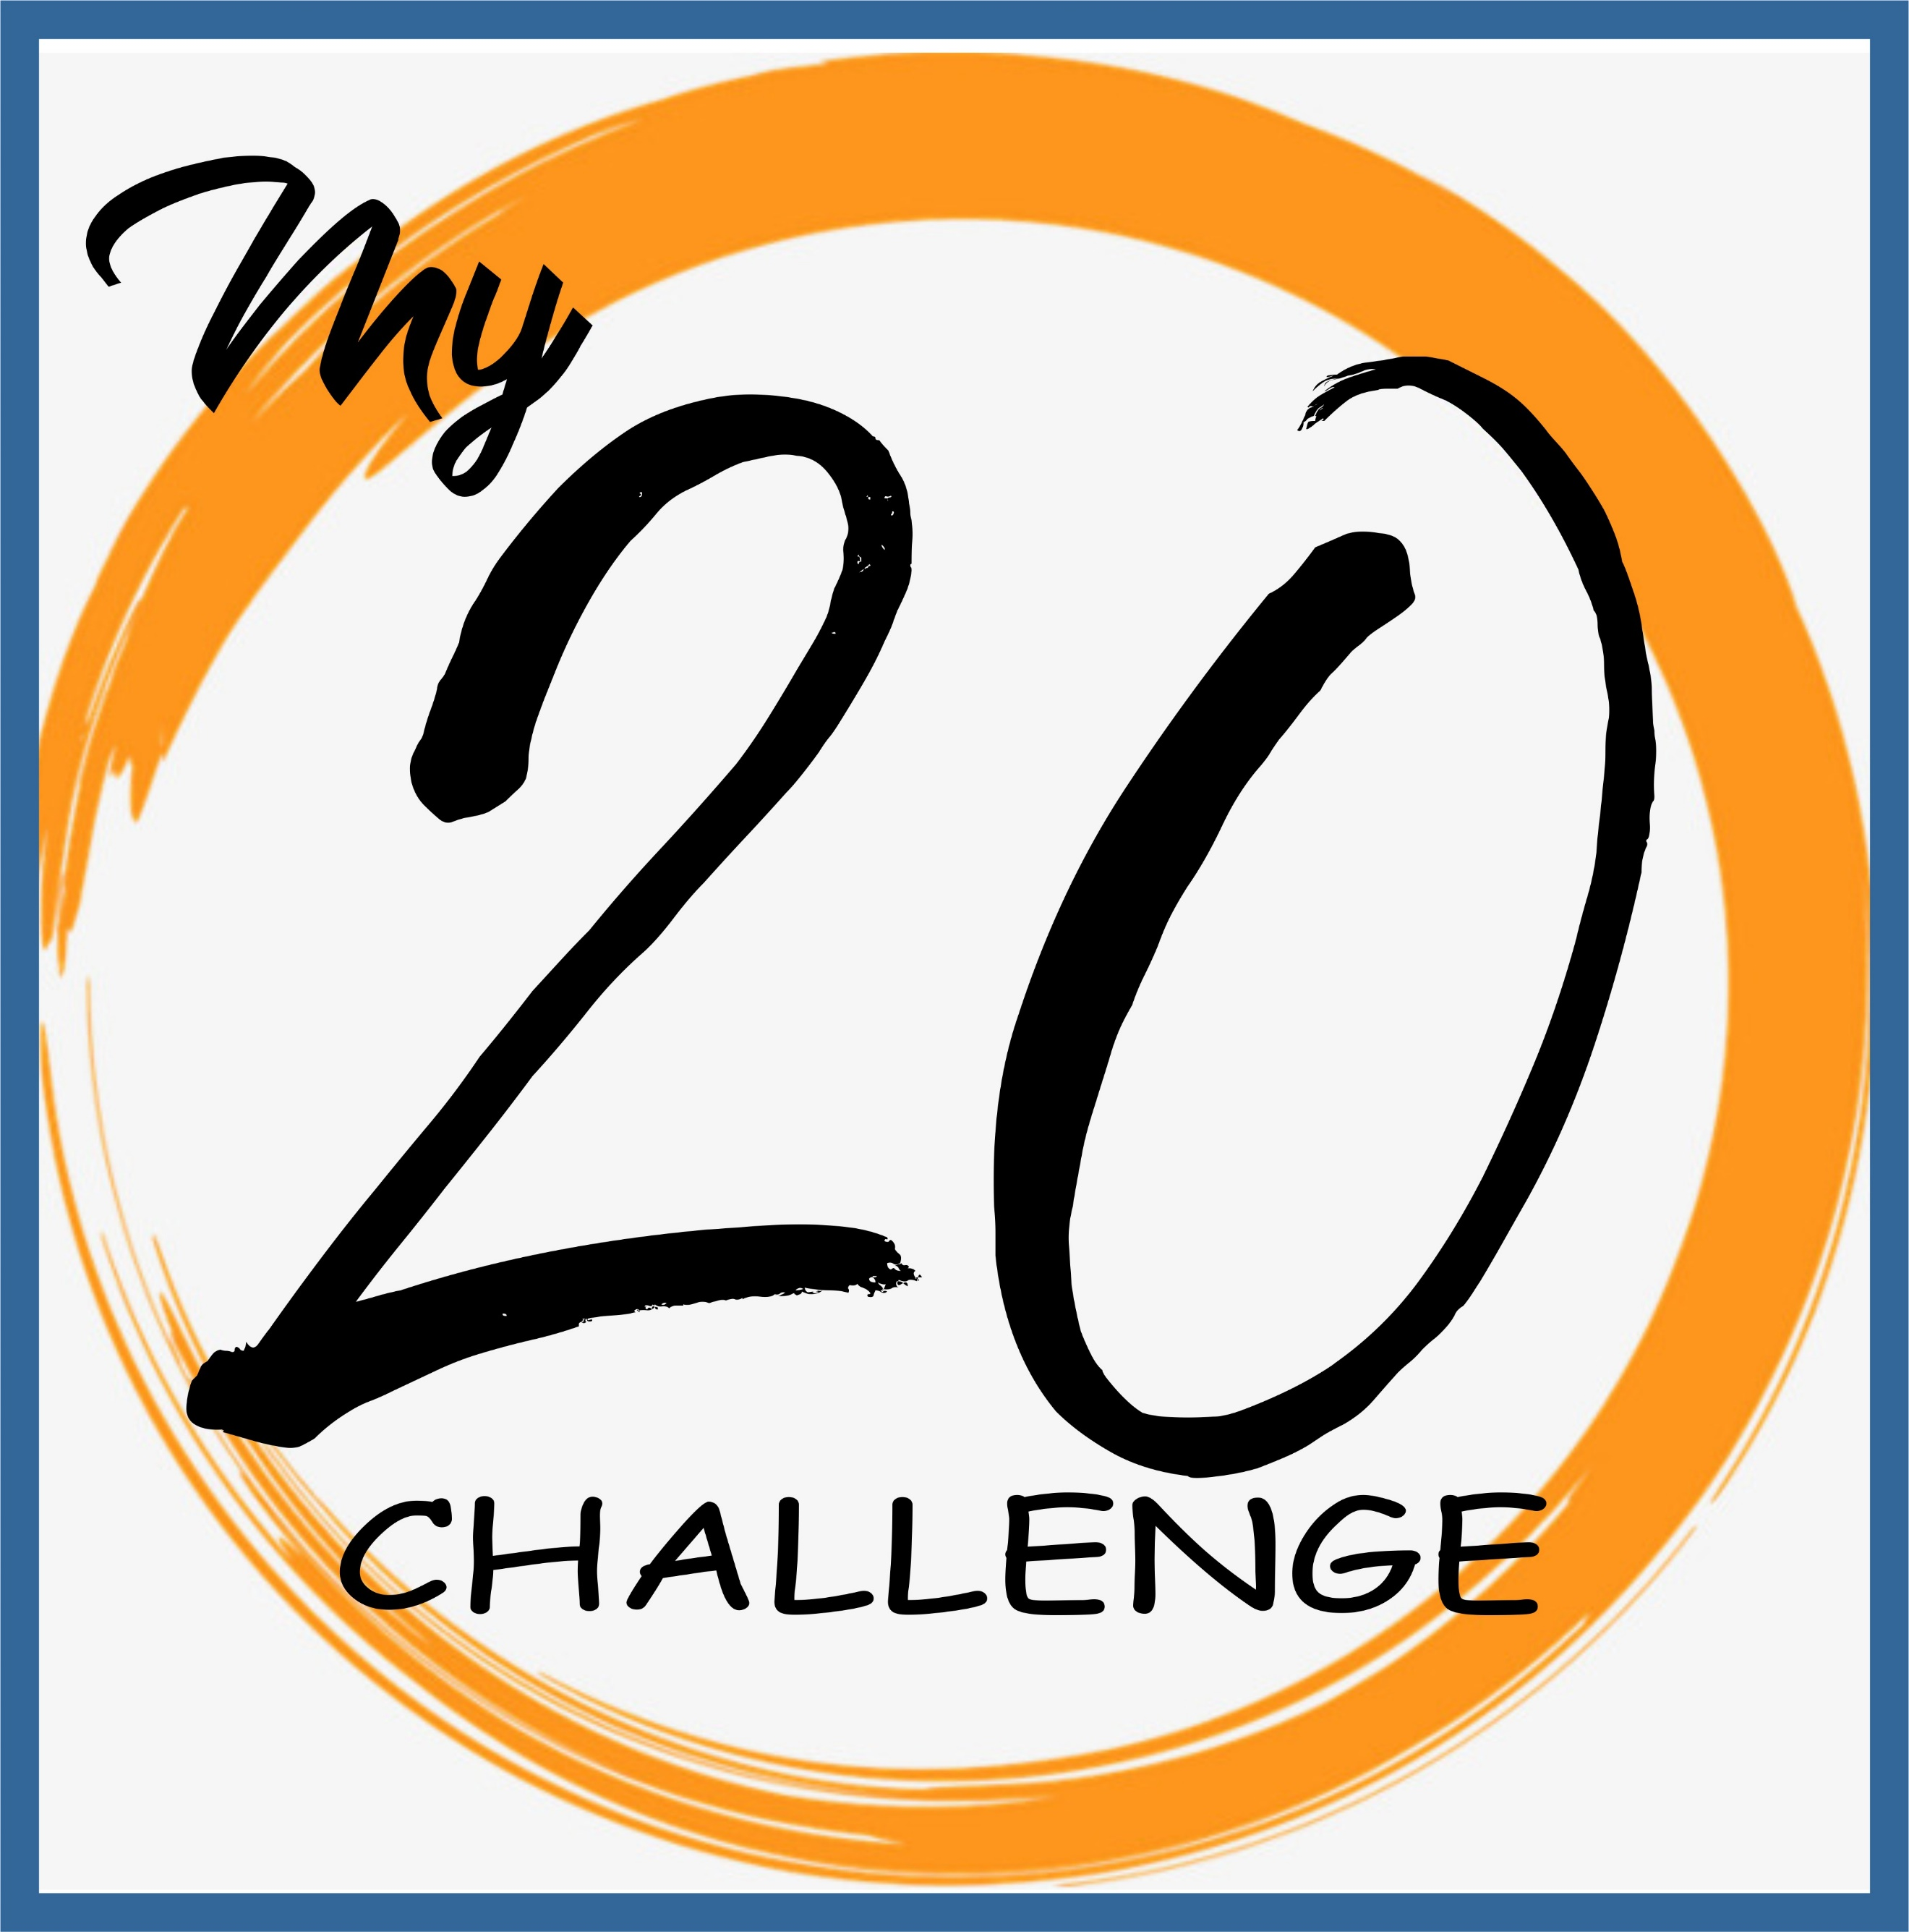
Invite to Church / Jesus:

Connection Points:
Acts of Kindness:

Read/Study the Word (20 minutes):

