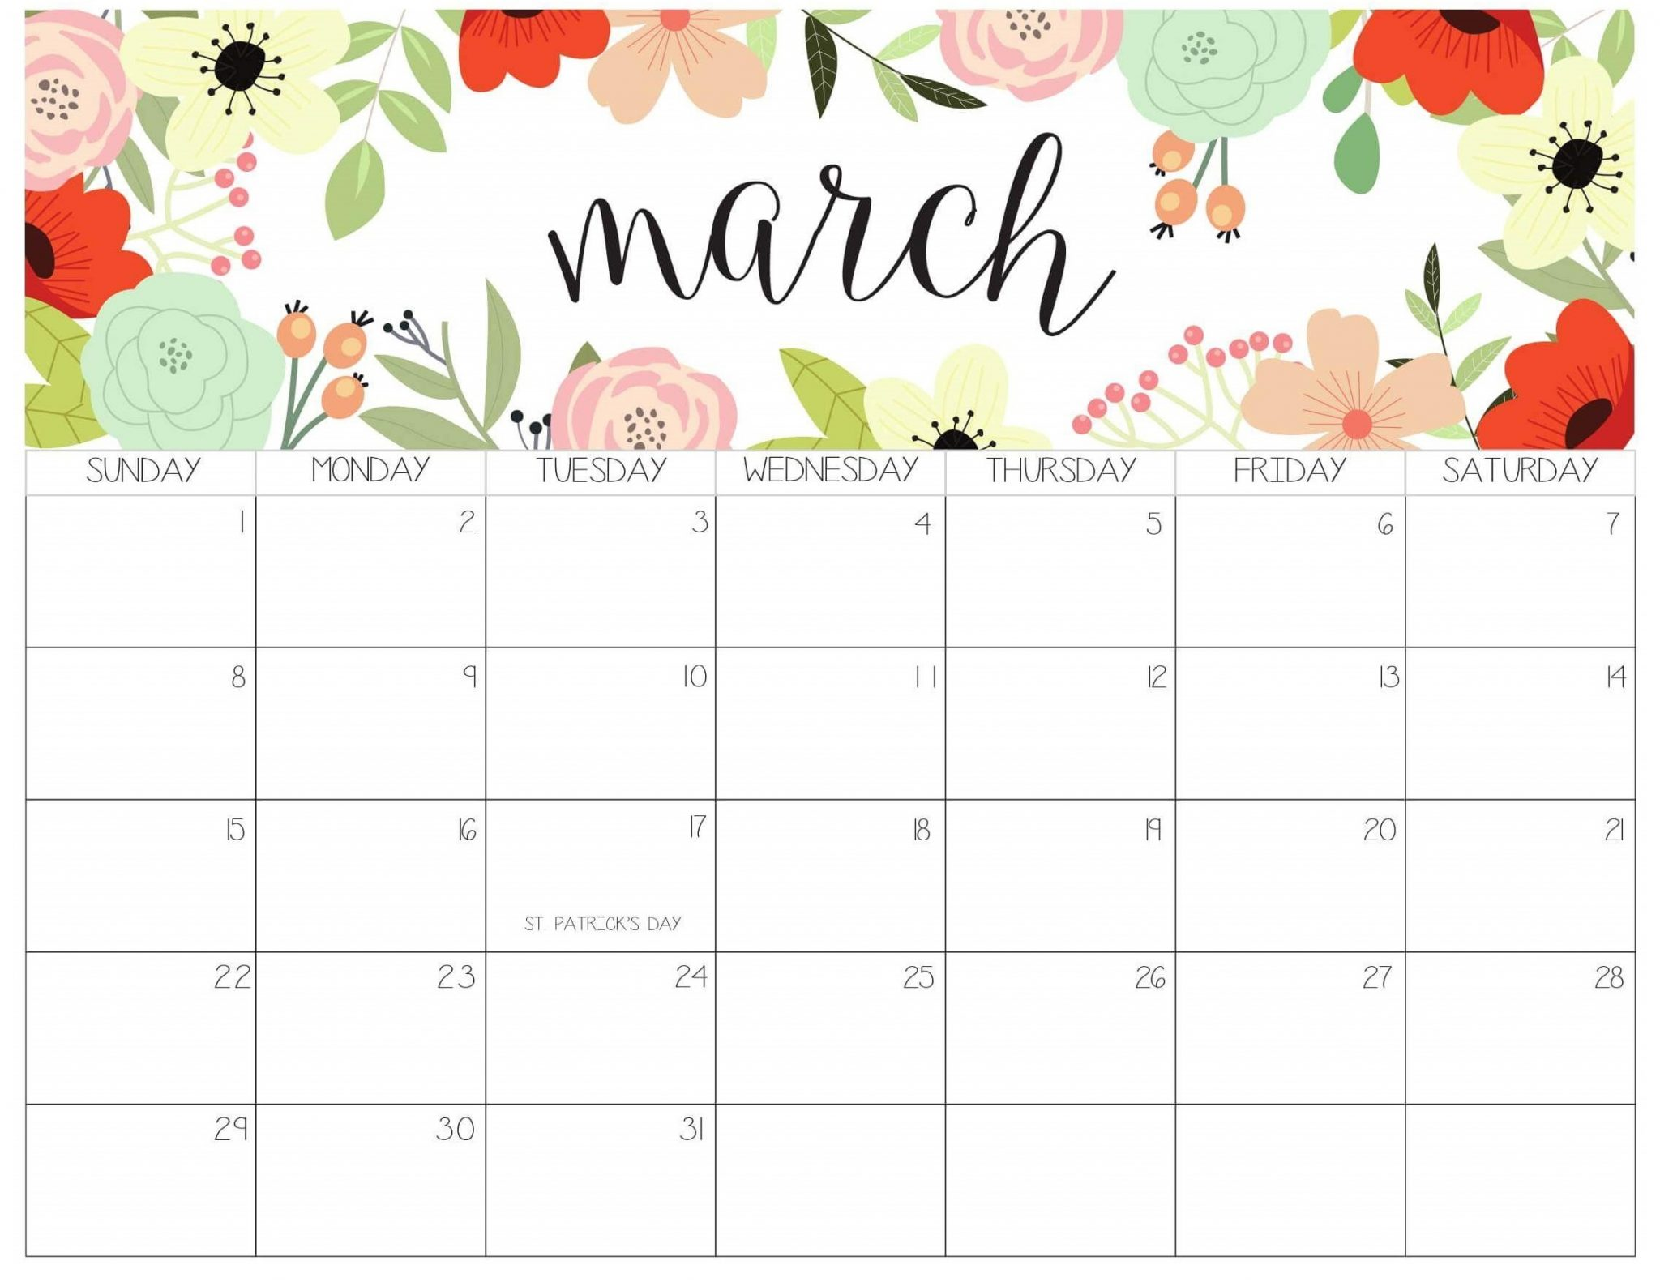

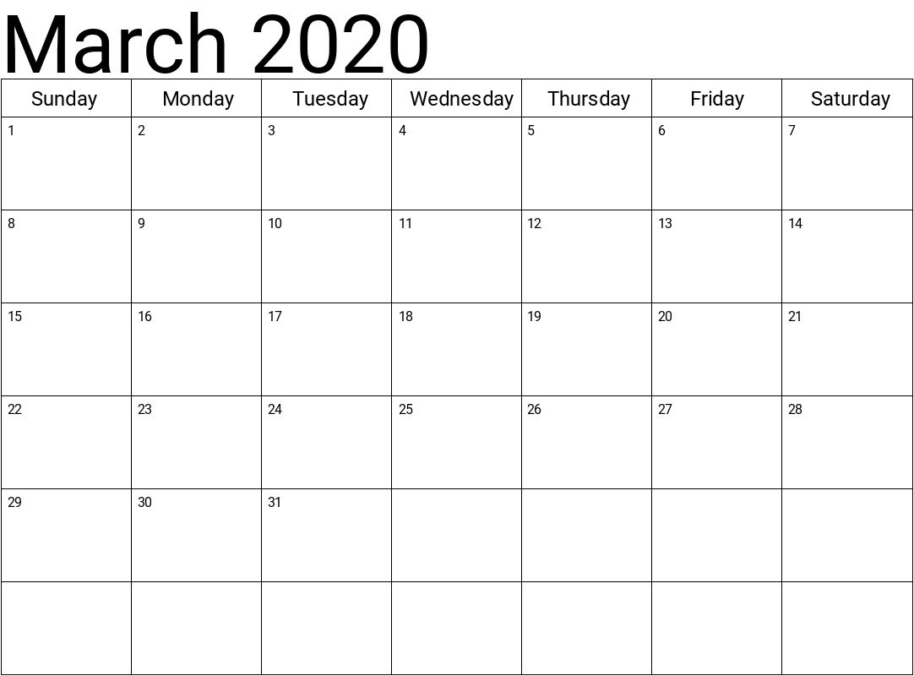

Work Day

*9am*

*Coffee & Donuts Provided*

Centennial Celebration Meeting

*6pm*

26 – David Meeks



2nd – Todd Musser 17th – Irma Richards 2nd – Dave & Eileen

3 – Nate Wells 18th – Leah Wells Alesso

4 – Jeanette Ransom 21 – Anton Peaker

11 – Addie Alvarado 23 – Sam Stevens

Council Meeting

*Following Worship Service*

YOUTH BUNCO

*12PM – 2PM*

Pizza, Prizes & FUN!!!

Bible Study

for all ages

@ 6:30pm

Bible Study

for all ages

@ 6:30pm

*Communion

*Board Meeting

*Following Worship Service*

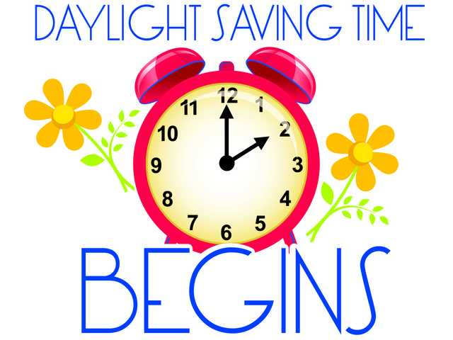



Coffee Muggers

*Marty Steelman’s*

*House @ 9:30am*

Panera

All are welcome.

8am

**Sunday Monday Tuesday Wednesday Thursday Friday Saturday**

Panera

All are welcome.

8am

Panera

All are welcome.

8am

Bible Study

for all ages

@ 6:30pm

Panera

All are welcome.

8am

Bible Study

for all ages

@ 6:30pm